https://developer.mozilla.org/en-US/docs/Learn/Getting_started_with_the_web/:
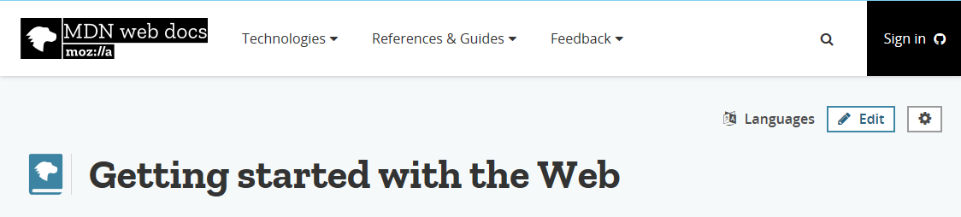
Getting Started with the Web (developer.mozilla.org)

